Lipunov Vladimir Mikhailovich
Partly from the book "Professors of Moscow State University"
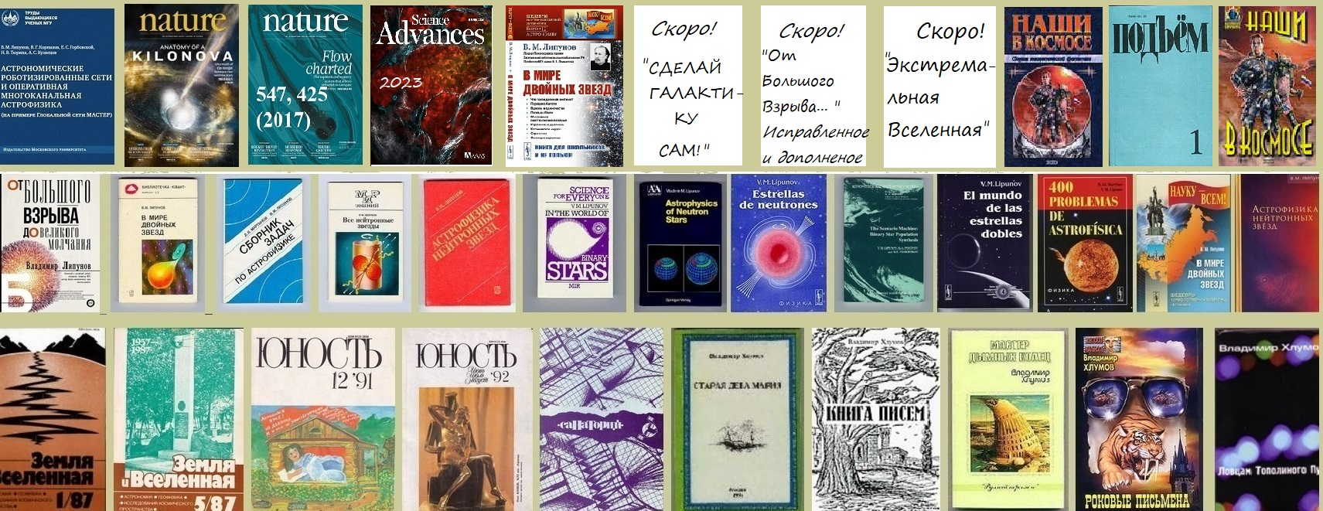
Lipunov Vladimir Mikhailovich was born on August 17, 1952 in Raichikhinsk, Amur Region. in the family of a worker.
Father - Mikhail Kornilovich Lipunov (1917-1990), - a driver.
Mother - Lipunova (Zhadko) Vera Stepanovna - teacher (1920-1983).
Lipunov V.M. He finished physics and mathematics school N145 in Kiev and attended the Kiev Palace of Pioneers,
where he learned a lot from his first teacher-astronomer Yuri Konstantinovich Filippov.
Graduated from the Physics Department of Moscow State University (1976). Qualifications: astronomer,
then postgraduate studies at the Faculty of Physics (1981) under the guidance of Academician Ya.B. Zel'dovich.
Professors of the astronomy department S.B. Pikelner, D.Ya. Martynov and especially N.I.Shakura had a great influence.
Candidate of Physical and Mathematical Sciences ("Accretion on Magnetized Compact Objects", 1982),
Doctor of Physical and Mathematical Sciences ("Theory of Evolution and Astrophysical Manifestations of Neutron Stars", 1991).
Professor of the Department of Astrophysics and Stellar Astronomy, Faculty of Physics (1993).
Member of the European Astronomical Society.
Laureate of the All-Soviet Union Competition of the Knowledge Society (1987).
Research interests: relativistic astrophysics. Topic of Ph.D. thesis: "Accretion of matter on magnetized compact objects".
Subject of doctoral dissertation: "Evolution and astrophysical manifestations of neutron stars".
He developed a complete classification of neutron stars as magnetized rotating gravitating bodies,
developed the theory of their evolution, originally formulated by V.F. Shvartsman (1982, 1984).
He put forward the idea and led the creation of the so-called "Scenario Machine", which allows to
numerically simulate the joint evolution of relativistic and ordinary stars. Together with V.G. Kornilov, he was
the first to carry out a numerical simulation of the evolution of massive binary stars, which showed
that the formation of neutron stars is accompanied by anisotropic energy release (1984). Together with K.A. Postnov,
he was the first to calculate the stochastic gravitational-wave spectrum generated by the binary stars of our Galaxy (1987),
and later, together with M.E. Prokhorov and K.A. Postnov, he calculated a similar spectrum of the Universe.
Performed a number of works on the dynamics of gas disks of galaxies, active galactic nuclei, large-scale structure of the Universe.
In 2002, together with A.V. Krylov and V.G. Kornilov, he created the first robotic telescope in Russia for observing cosmic gamma-ray bursts in the optical range.
Since 1982 he has been giving lecture courses "Theoretical astrophysics", "Astrophysics of neutron stars and black holes",
conducts seminars on the course "General astrophysics".
Prepared ~ 20 candidates of science. Of these, by 2023, four doctors of physical and mathematical sciences. (professors).
Published over 5000 scientific papers and Circulars.
Major works: "Stars and stellar systems" (co-author, 1981), "Collection of problems in astrophysics" (co-author D.Ya. Martynov, 1986), "In the world of double stars" (1986; published in English. , 1989),
Astrophysics of Neutron Stars (1987; published in English, 1992), All Neutron Stars (1988), Scenario Machine: Population Synthesis of Binary Stars (co-authors K.A. Postnov and M .E. Prokhorov, 1996. England),
"From the Big Bang to the Great Silence" (AST, Moscow, 2018).
Honorary Professor of the Moscow State University. MV Lomonosov, professor of the Department of Astrophysics and Stellar Astronomy of Moscow State University, Soros professor,
(I emphasize that we are talking about the Soros program for the support of natural sciences, which was headed by VN Soifer, for which he is very grateful. I consider Soros harmful.),
Head of the Space Monitoring Laboratory, member of the Writers' Union of Russia, Honored Worker of Higher Professional Education of Russia,
Editor-in-Chief of the literary Internet magazine "Russian Binder" Author of books, monographs and teaching aids.
Laureate of the Lomonosov Prize of Moscow State University in 2004.
Bredikhin Prize of the Russian Academy of Sciences for the prediction of the dominance of black holes on the
LIGO / Virgo gravitational wave detectors (2016). Prize named after Alexander Belyaev "For the best original educational book of the year in Russian".
Winner of the 1st Lomonosov Moscow State University Fine Arts Festival.

Scientific publications: > 5000 (this is not a typo) scientific publications as of June 22, 2023 Main projects:

The Scenario Machine started in 1983, now all the leading countries of the world are working on this principle. But so far nothing more perfect has been created. And this is the population synthesis of the Universe.

Russian binding - over 15 years.

Moscow Seminar of Astrophysicists - over 15 years.

Russian Binding Friday nights - over 15 years.

Global robotic network MASTER of space monitoring - since 2002.
Honorary Professor of Lomonosov Moscow State UniversityThe Principal Investigator of MASTER Global Robotic Net http://observ.pereplet.ru
Professor of Lomonosov Moscow State University Physics Department,
The Head of Space monitoring laboratory of Sternberg Astronomical Institute of Lomonosov MSU

VM Lipunov also published several novels and stories under the pseudonym Vladimir Khlumov ("Sanatorium" 1989, "The Master of Smoky Rings", 2000., "Fatal Letters", 2002. "Book of Letters", 1997, "Old Virgin Mary" 1997 ). In 1999 he founded a literary magazine and social, cultural, scientific and educational portal "Russian Binder" (www.pereplet.ru).

